Arrays

1. Array Initialization and Manipulation:
   1. Create an array of 5 numbers.
   2. Add a number to the end of the array.
   3. Remove the first number from the array.
   4. Print the final array.

let array=[1,2,3,4,5];

console.log("Original array:"+array);

array.push(6);

console.log("After adding number at end:"+array);

array.shift();

console.log("After removing first number:"+array);

console.log("Final array is:");

console.log(array);

Output:

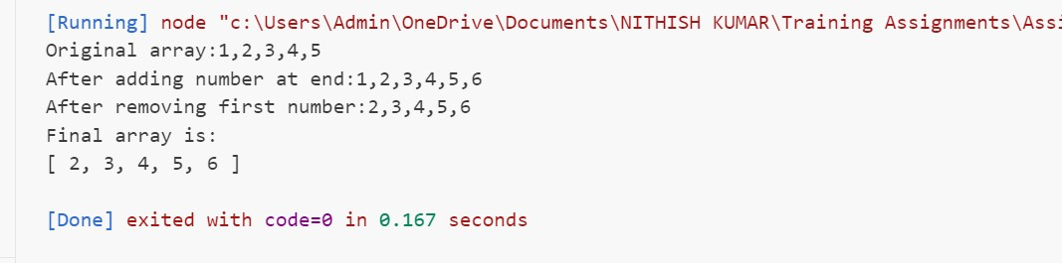

1. String Lengths in Array:
   1. Write a function that takes an array of strings and returns an array of their lengths.

let array=["car","bike","train","ship","plane"];

let lengths=[];

let strlen;

function ArrStrings(array){

    for(let i=0;i<array.length;i++){

        strlen= array[i].length;

        lengths.push(strlen);

    }

}

ArrStrings(array);

console.log("Given array of strings is:");

console.log(array);

console.log("Array of lengths of each string are:");

console.log(lengths);

Output:  
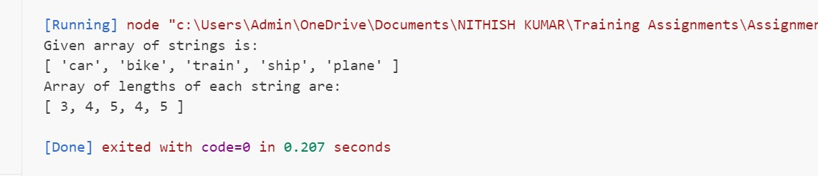

1. Filter Even Numbers:
   1. Write a function that takes an array of numbers and returns a new array containing only the even numbers.

let num=[1,2,3,4,5,6,7,8,9,10,11,12];

let evens=[];

function Even(x){

    for(let i=0;i<x.length;i++){

        if(x[i]%2==0){

            evens.push(x[i]);

        }

    }

}

console.log("Given array is:");

console.log(num);

Even(num);

console.log("Array of even numbers is:");

console.log(evens);

Output:

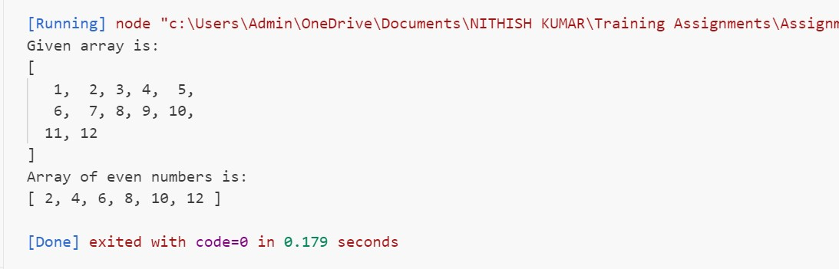

1. Reverse Strings:
   1. Write a function that takes an array of strings and returns a new array with each string reversed.

let strings=["Apple","Mango","Orange","Banana"];

let reverse=[];

function ReverseString(x){

    for(let i=0;i<x.length;i++){

        let s=x[i];

        let s2="";

        for(let j=s.length-1;j>=0;j--){

            s2=s2+s[j];

        }

        reverse.push(s2);

    }

    console.log(reverse);

}

console.log("Given array is:");

console.log(strings);

console.log("Array of reversed strings is:");

ReverseString(strings);

Output:

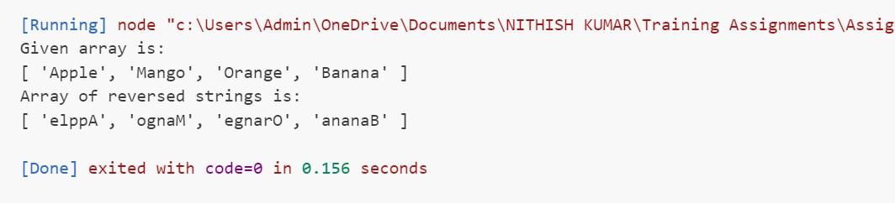

1. Sum of Array Elements:
   1. Write a function that takes an array of numbers and returns the sum of all the numbers.

let num=[2,5,7,6,3];

let sum=0;

function SumOfNum(x){

    for(let i=0;i<num.length;i++){

        sum=sum+num[i];

    }

}

console.log("Given array is:");

console.log(num);

SumOfNum(num);

console.log("Sum of all numbers of array is: "+sum);

Output:  
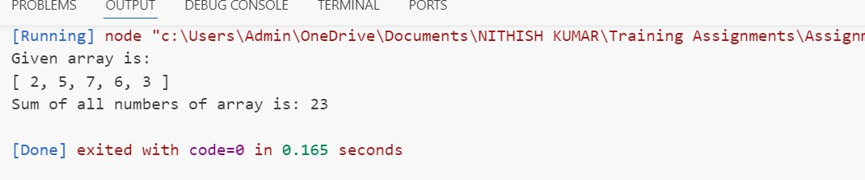

1. Find Longest String:
   1. Write a function that takes an array of strings and returns the longest string.

let array=["Volvo","Lamborgini","BMW","Mahindra"];

function Longest(x){

    long=x[0].length;

    for(let i=1;i<x.length;i++){

        if(x[i].length>long){

            long=x[i];

        }

    }

}

console.log("Given array is:");

console.log(array);

Longest(array);

console.log("Longest string is: "+long);

Output:

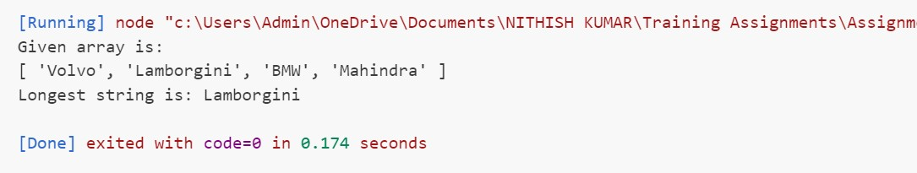

1. String Contains Character:
   1. Write a function that takes an array of strings and a character, and returns an array of strings that contain that character.

let array=["car1","car2","car3","car4"];

let a='c';

function Items(x,y){

    for(let i=0;i<array.length;i++){

        array[i]+=a;

    }

}

console.log("Given array is:");

console.log(array);

console.log("Given character is: "+a);

Items(array,a);

console.log("Array of strings contains the character is:");

console.log(array);

Output:

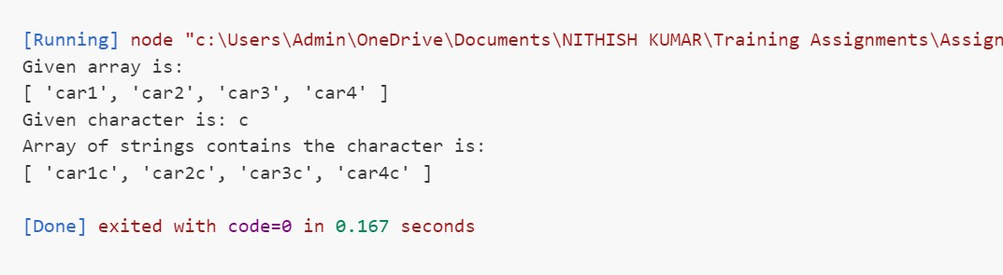

1. Concatenate Array of Strings:
   1. Write a function that takes an array of strings and returns a single string that is the concatenation of all the strings.

let strings=["Apple","Mango","Orange","Banana"];

let final="";

function Concat(a){

   for(let i=0;i<strings.length;i++){

        final=final+strings[i];

   }

   return final;

}

console.log("Given array is:");

console.log(strings);

Concat(strings);

console.log("Concatenation of all strings is: "+final);

Output:

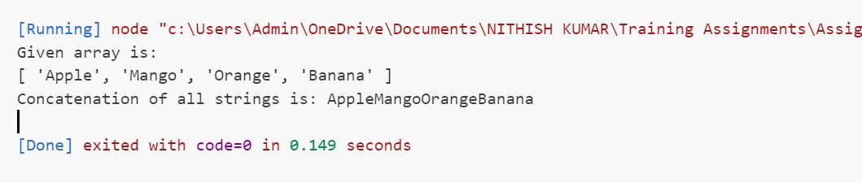

1. Capitalize First Letter:
   1. Write a function that takes an array of strings and returns a new array with the first letter of each string capitalized.

let array=["car","bike","train","ship","plane"];

let final=[];

let str;

function Caps(a){

    for(let i=0;i<array.length;i++){

        str=array[i];

        let cap=str[0].toUpperCase();

        let s2="";

        for(let j=1;j<str.length;j++){

            s2+=str[j];

        }

        str=cap+s2;

        final.push(str);

    }

    return final;

}

console.log("Given array is:");

console.log(array);

Caps(array);

console.log("Final array with first letter of strings is capital:");

console.log(final);

Output:

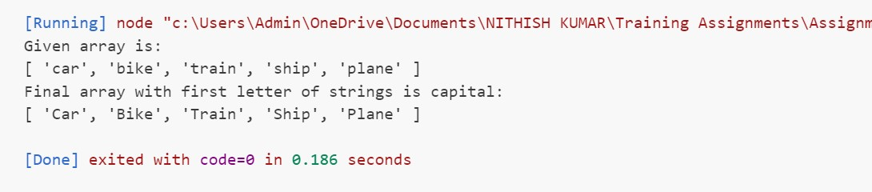

1. Flatten Nested Arrays:
   1. Write a function that takes a nested array (an array of arrays) and returns

let nest=[[1,2,3],[4,5,6],[7,8,9,10]];

function nestedArray(x){

    for(let i=0;i<nest.length;i++){

        for(let j=0;j<nest[i].length;j++){

            console.log(nest[i][j]);

        }

    }

}

console.log("Nested array is:");

console.log(nest);

console.log("Elements of nested array are:");

nestedArray(nest);

Output:

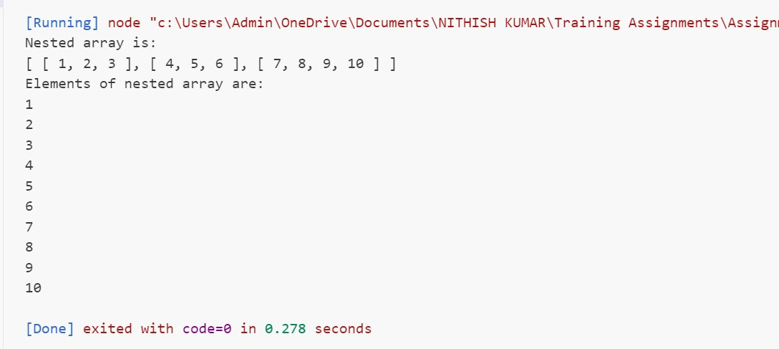

1. Count Occurrences:
   1. Write a function that takes an array of strings and returns an object where the keys are the strings and the values are the number of times each string appears in the array.

let array=["car","bus","bike","car","car","bus"];

function Object(x){

    console.log("Given array is:");

    console.log(x);

    console.log("Keys and values of object are:");

    for(let i=0;i<x.length;i++){

        let count=0;

        let s=x[i];

        for(let j=0;j<x.length;j++){

            if(s==x[j]){

                count=count+1;

            }

        }

        console.log(s+":"+count);

    }

}

Object(array);

Output:

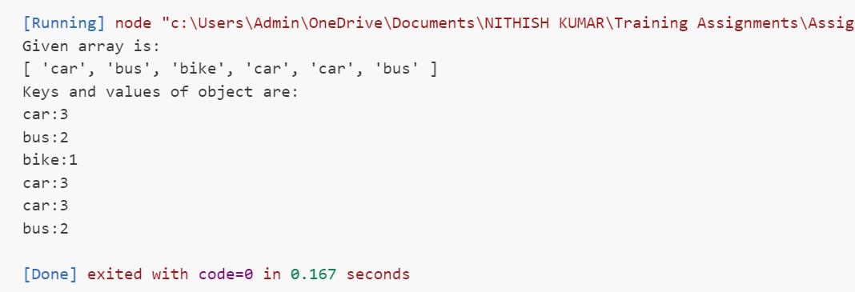

1. Remove Duplicates:
   1. Write a function that takes an array of numbers and returns a new array with all duplicate elements removed.

let num=[2,4,6,5,2,5,4,2,1];

let unique=[];

        function RemoveDuplicates(num) {

            num.forEach(element => {

            if (!unique.includes(element)) {

                unique.push(element);

                }

            });

        }

    console.log("Array of numbers is:");

    console.log(num);

    RemoveDuplicates(num);

    console.log("After removing duplicates:");

    console.log(unique);

Output:

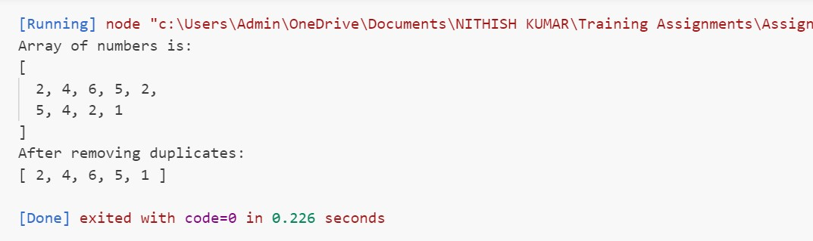

1. Find Index of String:
   1. Write a function that takes an array of strings and a string, and returns the index of the string in the array. If the string is not found, return -1.

let array=["item1","item2","item3","item4","item5"];

let s="item3";

function Search(x,y){

    if(x.includes(y)){

        console.log("Index of \""+y+"\" is: "+x.indexOf(y));

    }

    else{

        console.log("-1");

    }

}

console.log("Array is:");

console.log(array);

Search(array,s);

Output:

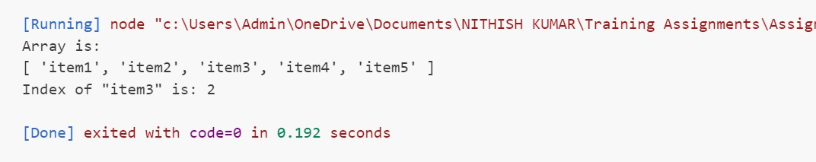

1. Sort Strings Alphabetically:
   1. Write a function that takes an array of strings and returns a new array with the strings sorted alphabetically.

let array=["Mango","Dog","Hotel","Apple","India"];

//let sort=[];

function Sorted(a){

    a.sort();

    console.log("After sorting array is:");

    console.log(array);

}

console.log("Array is:");

console.log(array);

Sorted(array);

Output:

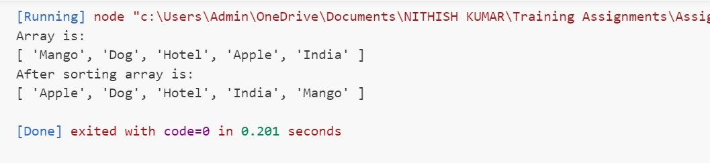

1. Sum of Square of Numbers:
   1. Write a function that takes an array of numbers and returns the sum of the squares of those numbers.

let num=[1,2,3,4,5,6];

let squares=[];

let sum=0;

function SumOfSqures(x){

    for(let i=0;i<num.length;i++){

        let s=num[i]\*num[i];

        sum=sum+s

    }

    console.log("Sum of squares of numbers is: "+sum);

}

console.log("Array is:");

console.log(num);

SumOfSqures(num);

Output:

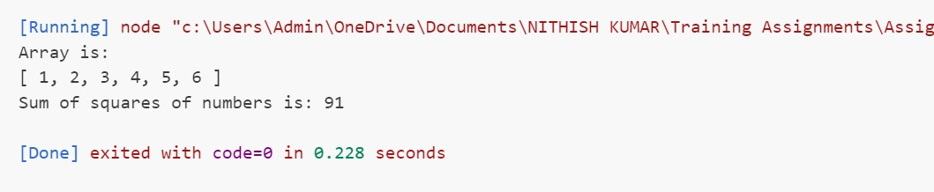

1. Convert Strings to Uppercase:
   1. Write a function that takes an array of strings and returns a new array with all the strings converted to uppercase.

let array=["Volvo","Lamborgini","BMW","Mahindra"];

function UpperCase(x){

    let caps=[];

    for(let i=0;i<x.length;i++){

        let s=x[i].toUpperCase();

        caps.push(s);

    }

    console.log("Strings with uppercase are:");

    console.log(caps);

}

console.log("Array is:");

console.log(array);

UpperCase(array);

Output:

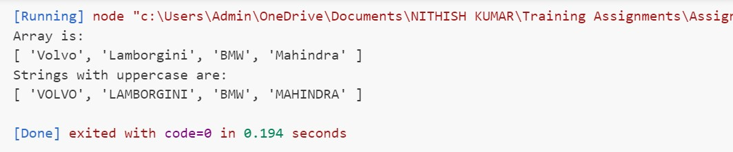

1. Find Common Elements:
   1. Write a function that takes two arrays of numbers and returns a new array containing the common elements from both arrays.

let num1=[1,2,3,4,5,6,7,8];

let num2=[0,2,4,6,8,10,12];

function Common(x,y){

    let num3=[];

    for(let i=0;i<x.length;i++){

        if(y.includes(x[i])){

            num3.push(x[i]);

        }

    }

    console.log("Given arrays are:")

    console.log(x);

    console.log(y);

    console.log("Common elements are:");

    console.log(num3);

}

Common(num1,num2);

Output:

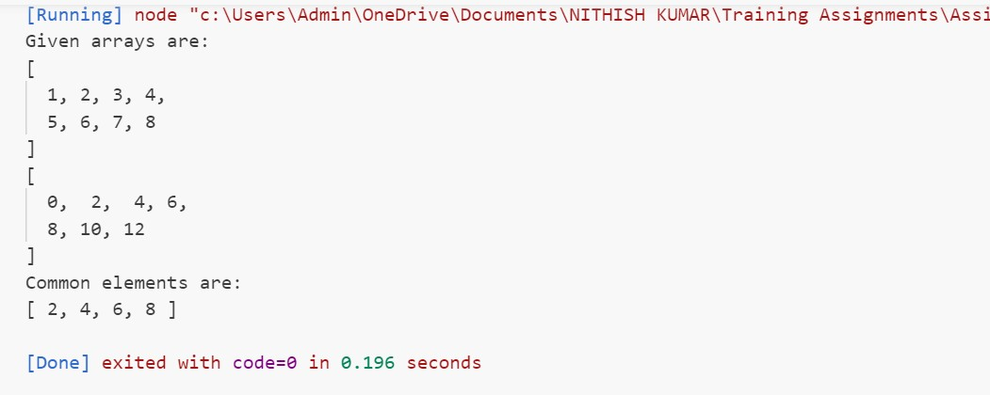

1. Remove Falsy Values:
   1. Write a function that takes an array and returns a new array with all falsy values (false, 0, "", null, undefined, NaN) removed.

let array=["Item1",201,"",undefined,null,"item2",false,0,500,NaN];

function RemoveFalsy(x){

    let z=[];

    let falsy=[false,0,"",null,undefined,NaN];

    for(let i=0;i<x.length;i++){

            if(!falsy.includes(x[i])){

                z.push(x[i]);

            }

        }

        console.log("Given array is:");

        console.log(x);

        console.log("After removing falsy values:");

        console.log(z);

    }

RemoveFalsy(array);

Output:

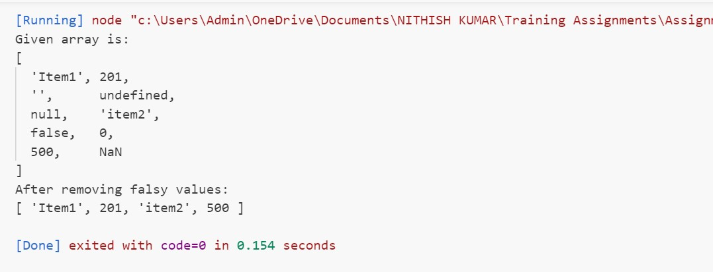

1. Find Unique Characters:
   1. Write a function that takes a string and returns an array of unique characters in the string.

let string="HTMLCSSJAVASCRIPT";

function Unique(x){

    let s2=[];

    for(let i=0;i<x.length;i++){

        if(!s2.includes(x[i])){

            s2.push(x[i]);

        }

    }

    console.log("String is: "+x);

    console.log("Array of unique characters is:");

    console.log(s2);

}

Unique(string);

Output:

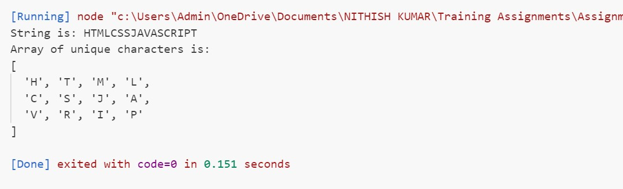

1. Merge and Sort Arrays:
   1. Write a function that takes two sorted arrays of numbers and returns a single sorted array that combines both arrays.

let num1=[6,7,10,4,2,9];

let num2=[8,1,12,3,5];

num1.sort();

num2.sort();

function SortedArray(x,y){

    let z=x.concat(y);

    z.sort();

    console.log("Given arrays are:");

    console.log(x);

    console.log(y);

    console.log("Sorted array by combining two arrays is:");

    console.log(z);

}

SortedArray(num1,num2);

Output:

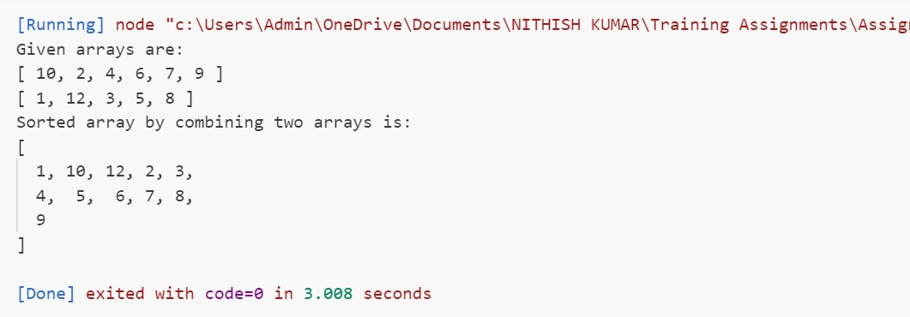

1. Count Occurrences:
   1. Write a function that takes an array of strings and returns an object where the keys are the strings and the values are the number of times each string appears in the array.

let array=["car","bus","bike","car","car","bus"];

function Object(x){

    console.log("Given array is:");

    console.log(x);

    console.log("Keys and values of object are:");

    for(let i=0;i<x.length;i++){

        let count=0;

        let s=x[i];

        for(let j=0;j<x.length;j++){

            if(s==x[j]){

                count=count+1;

            }

        }

        console.log(s+":"+count);

    }

}

Object(array);

Output:



1. Remove Duplicates:
   1. Write a function that takes an array of numbers and returns a new array with all duplicate elements removed.

let num=[2,4,6,5,2,5,4,2,1];

let unique=[];

        function RemoveDuplicates(num) {

            num.forEach(element => {

            if (!unique.includes(element)) {

                unique.push(element);

                }

            });

        }

    console.log("Array of numbers is:");

    console.log(num);

    RemoveDuplicates(num);

    console.log("After removing duplicates:");

    console.log(unique);

Output:



1. Find Index of String:
   1. Write a function that takes an array of strings and a string, and returns the index of the string in the array. If the string is not found, return -1.

let array=["item1","item2","item3","item4","item5"];

let s="item3";

function Search(x,y){

    if(x.includes(y)){

        console.log("Index of \""+y+"\" is: "+x.indexOf(y));

    }

    else{

        console.log("-1");

    }

}

console.log("Array is:");

console.log(array);

Search(array,s);

Output:



1. Sort Strings Alphabetically:
   1. Write a function that takes an array of strings and returns a new array with the strings sorted alphabetically.

let array=["Mango","Dog","Hotel","Apple","India"];

function Sorted(a){

    a.sort();

    console.log("After sorting array is:");

    console.log(array);

}

console.log("Array is:");

console.log(array);

Sorted(array);

Output:



1. Sum of Square of Numbers:
   1. Write a function that takes an array of numbers and returns the sum of the squares of those numbers.

let num=[1,2,3,4,5,6];

let squares=[];

let sum=0;

function SumOfSqures(x){

    for(let i=0;i<num.length;i++){

        let s=num[i]\*num[i];

        sum=sum+s

    }

    console.log("Sum of squares of numbers is: "+sum);

}

console.log("Array is:");

console.log(num);

SumOfSqures(num);

Output:  
 

1. Convert Strings to Uppercase:
   1. Write a function that takes an array of strings and returns a new array with all the strings converted to uppercase.

let array=["Volvo","Lamborgini","BMW","Mahindra"];

function UpperCase(x){

    let caps=[];

    for(let i=0;i<x.length;i++){

        let s=x[i].toUpperCase();

        caps.push(s);

    }

    console.log("Strings with uppercase are:");

    console.log(caps);

}

console.log("Array is:");

console.log(array);

UpperCase(array);

Output:



1. Find Common Elements:
   1. Write a function that takes two arrays of numbers and returns a new array containing the common elements from both arrays.

let num1=[1,2,3,4,5,6,7,8];

let num2=[0,2,4,6,8,10,12];

function Common(x,y){

    let num3=[];

    for(let i=0;i<x.length;i++){

        if(y.includes(x[i])){

            num3.push(x[i]);

        }

    }

    console.log("Given arrays are:")

    console.log(x);

    console.log(y);

    console.log("Common elements are:");

    console.log(num3);

}

Common(num1,num2);

Output:



1. Remove Falsy Values:
   1. Write a function that takes an array and returns a new array with all falsy values (false, 0, "", null, undefined, NaN) removed.

let array=["Item1",201,"",undefined,null,"item2",false,0,500,NaN];

function RemoveFalsy(x){

    let z=[];

    let falsy=[false,0,"",null,undefined,NaN];

    for(let i=0;i<x.length;i++){

            if(!falsy.includes(x[i])){

                z.push(x[i]);

            }

        }

        console.log("Given array is:");

        console.log(x);

        console.log("After removing falsy values:");

        console.log(z);

    }

RemoveFalsy(array);

Output:



1. Find Unique Characters:
   1. Write a function that takes a string and returns an array of unique characters in the string.

let string="HTMLCSSJAVASCRIPT";

function Unique(x){

    let s2=[];

    for(let i=0;i<x.length;i++){

        if(!s2.includes(x[i])){

            s2.push(x[i]);

        }

    }

    console.log("String is: "+x);

    console.log("Array of unique characters is:");

    console.log(s2);

}

Unique(string);

Output:



1. Merge and Sort Arrays:
   1. Write a function that takes two sorted arrays of numbers and returns a single sorted array that combines both arrays.

let num1=[6,7,10,4,2,9];

let num2=[8,1,12,3,5];

num1.sort();

num2.sort();

function SortedArray(x,y){

    let z=x.concat(y);

    z.sort();

    console.log("Given arrays are:");

    console.log(x);

    console.log(y);

    console.log("Sorted array by combining two arrays is:");

    console.log(z);

}

SortedArray(num1,num2);

Output:

